2.3 I can select and use appropriate editing and formatting techniques to aid both clarity and navigation

Here are the methods in which I can alter my images so that they are the right size for my website:

Paint:

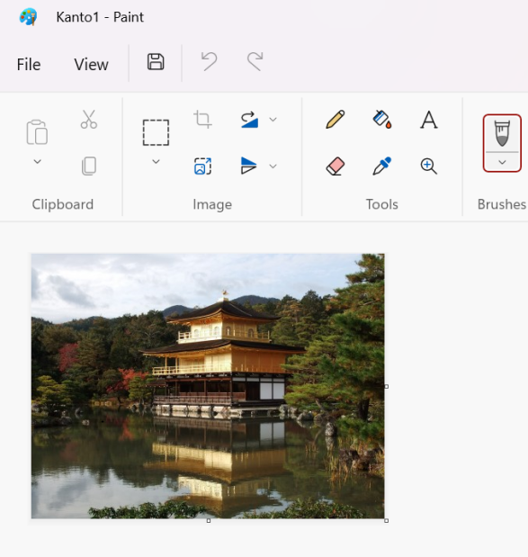

[The above image shows the file in paint and an arrow at what button I will press to resize the photo] 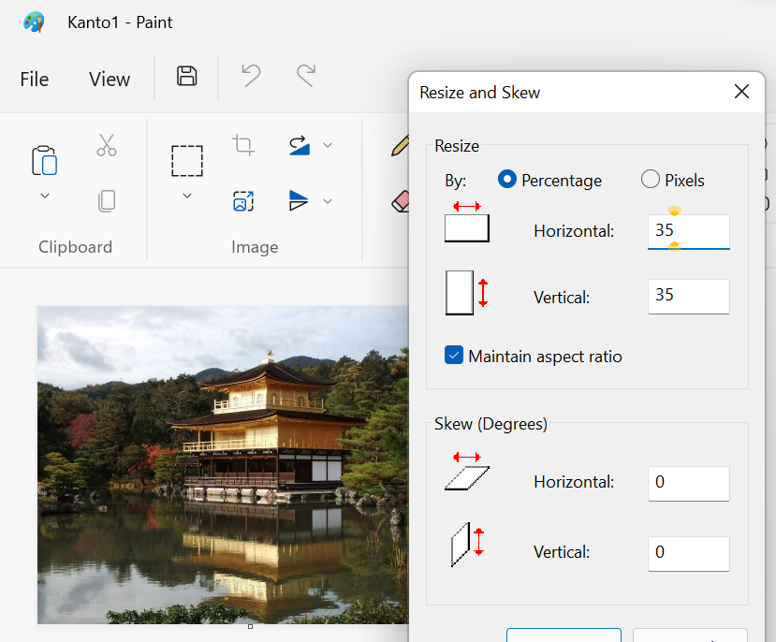

[The above image shows the resize window in paint that I can use to resize the picture, I have chose 35%]

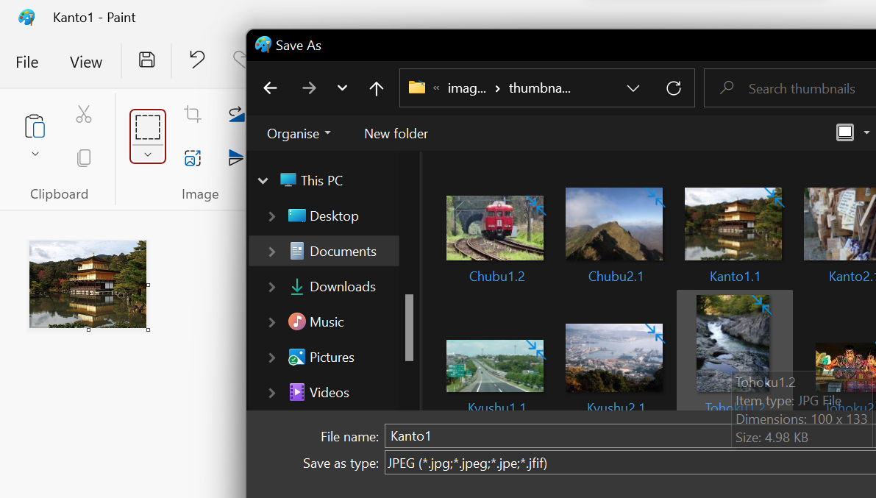

[The above image shows that I am saving the above photo in the appropriate folder with the appropriate file type, JPG, so that I can put it on my website]

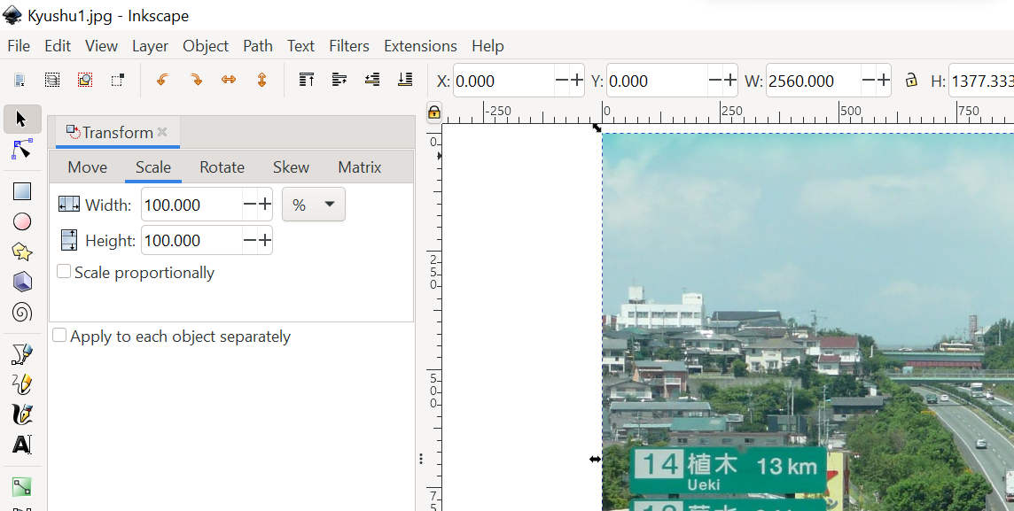

[The Above image shows the file in Inkscape and the transform toolbar open to resize the photo]

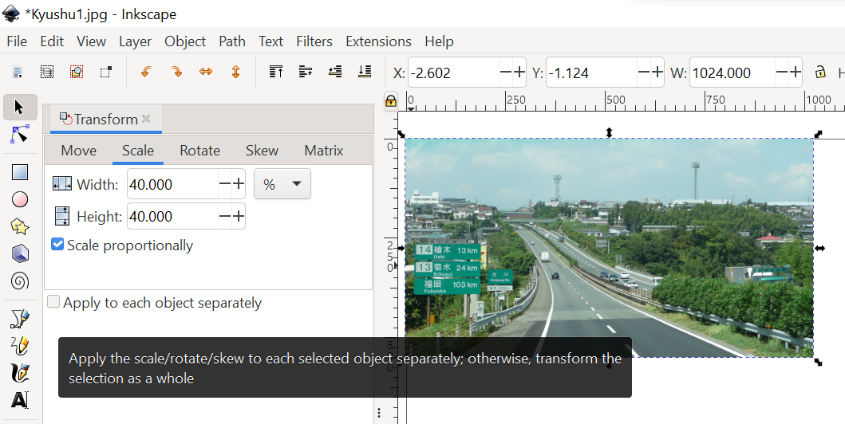

[The above photo shows that I have chose 40 width and 40 height reduction in size]

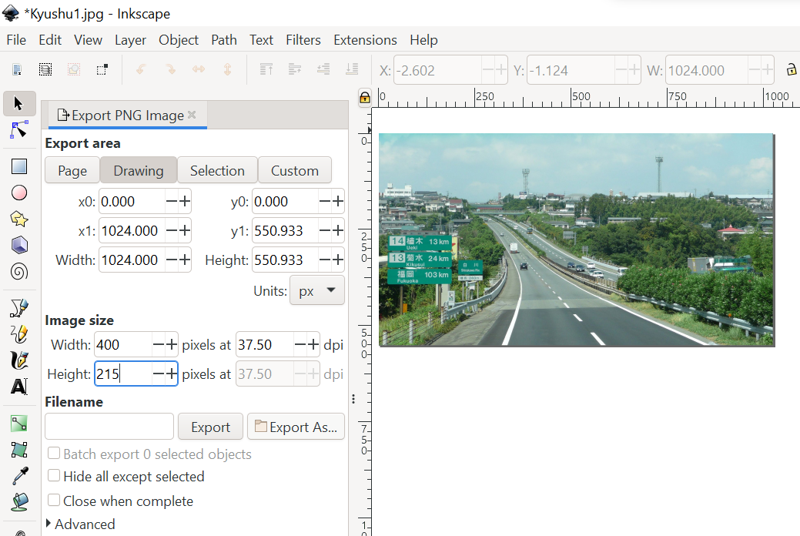 [The above photo shows that I have selected to export the image in a PNG image file and I would have saved it to appropriate folder]